SOLUTION DEVELOPMENT

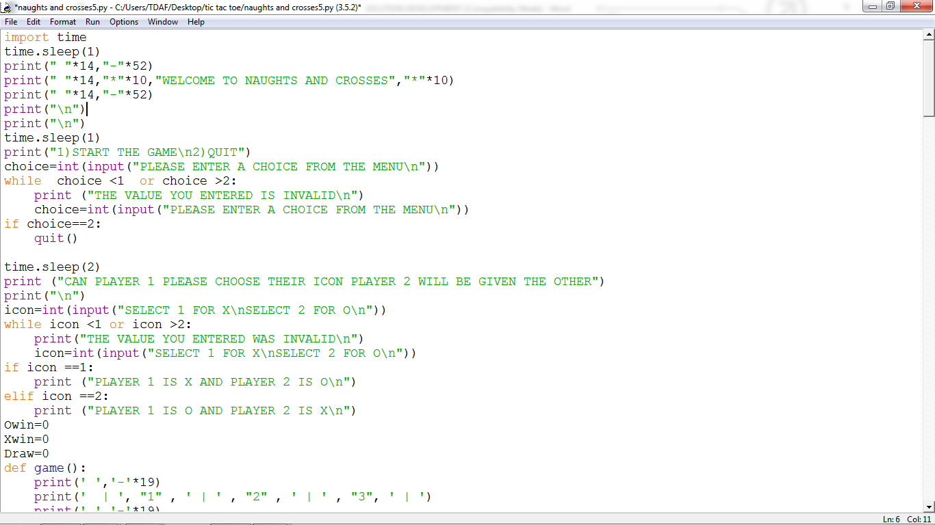

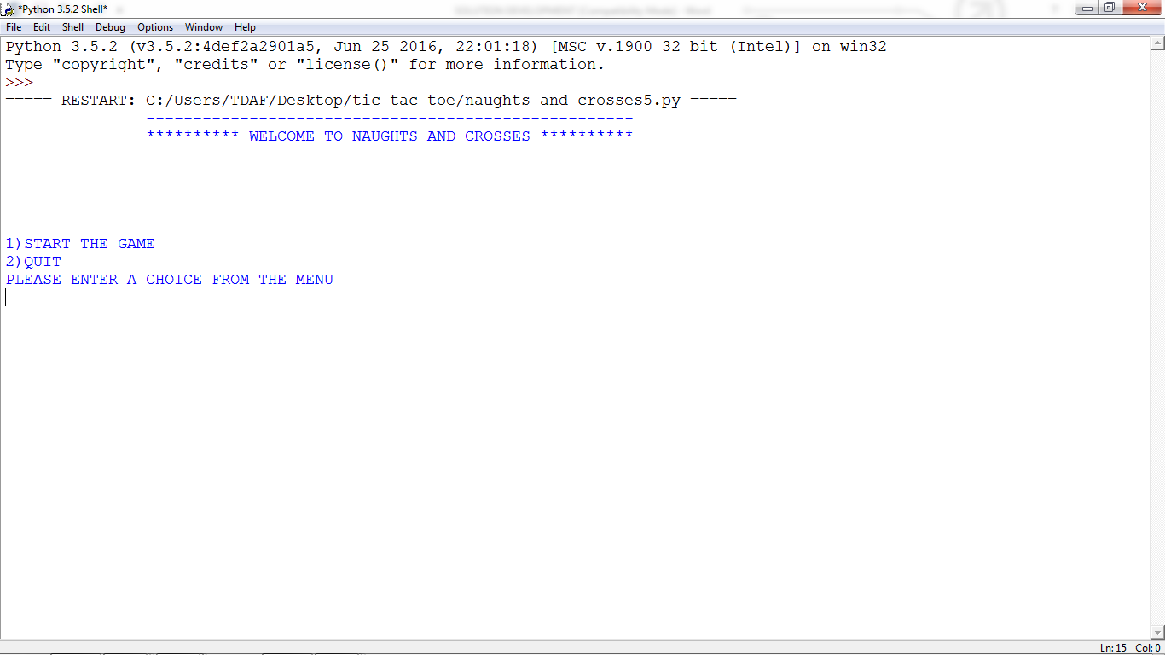

All the variables that I will be using throughout the code are defined at the start of the program, within the global area. By doing this I am able to avoid having to redefine them every time they are called anywhere else within the program.

In the screenshot above, the print function is used in order to output text to the user, an example of this is where I have made a large easy to see title with “*” on either side and appropriate spacing between it and the rest of my opening menu. I did this to attract the users’ attention and to make the program more appealing to the user.

The import module allows me to use other modules and functions in my work. This is an easy method as instead of me having to write out all the coding needed; python has provided that for me. I have imported a time delay function to put time delays between my coding. Doing this, means that the user will not be presented with too much information at once.

The while loop is included in the program for validation purposes. It allows the program to repeat certain parts of the code until a defined condition is met. This means, that no matter how many times the user enters invalid data, the program will keep reminding the user of the options they need to choose and how to choose the correct option. I have also used an IF statement to create extra options/ conditions for the user, also the coding is in capitals so when the code is displayed, the user can see and read them easily. The user is introduced to the game and gives the user the option to either play or quit the game. This also means that I will not have to keep re-writing each piece of coding if I intend to use it later thereby, making my coding more efficient. I have also added a quit option using the quit function that python has provided me with. This enables the user to abort the program if they want to.

As seen in the screenshot above, the time function separates the main menu from the next set of options that the user will be asked to choose from. I have done this so that there is time for the user to comfortably read and understand the rules.

Procedures have been used throughout the code in order to make looping sections of the program much easier. Procedures such as “maingame”, “game”, “x_place”, “o_place” have been frequently looped in order to update the game after each user interaction with the grid. Under the procedure “game” is all the code for the main game which includes the procedures “maingame”, “x_place” and “o_place”. The procedure “maingame” contains the code for the grid, this procedure is often repeated as the grid is updated after valid inputs from the user. Instead of an array I have created the grid using the print function and a list format. The procedure “x_place” contains the code used for selecting the grid space of the “x” icon this is one of the most frequently used procedures. The procedure “o_place” contains the code used for selecting the grid space of the “o” icon this is also one of the most frequently used procedures.

I have used iteration, this means that the game will repeat it’s self unless the user has won or the grid is filled. Iteration is also used after the game has been completed as the user is given the option of playing again.